Men’s Bible Study

Romans:11:1-6

Wednesday 29th of November

Session 29 of ?

Romans 11:1-6 NASB

I say then, God has not rejected His people, has He? Far from it! For I too am an Israelite, a descendant of Abraham, of the tribe of Benjamin.

God has not rejected His people whom He foreknew. Or do you not know what the Scripture says in the passage about Elijah, how he pleads with God against Israel?

“Lord, THEY HAVE KILLED YOUR PROPHETS, THEY HAVE TORN DOWN YOUR ALTARS, AND I ALONE AM LEFT, AND THEY ARE SEEKING MY LIFE.”

But what is the divine response to him? “I HAVE KEPT for Myself SEVEN THOUSAND MEN WHO HAVE NOT BOWED THE KNEE TO BAAL.”

In the same way then, there has also come to be at the present time a remnant according to God’s [d]gracious choice.

But if it is by grace, it is no longer on the basis of works, since otherwise grace is no longer grace.

Learning as action – A point of view
There is a difference between the Jews and Gentiles of the Roman period which is still true. For the Gentile world learning was something done at the guidance and mandate of authority. A Gentile of the time of the Book of Romans was one of lecture, explanation, guidance to conclusion. For the Jew, learning is an experience of personal, self-led discovery, where we have enough tools at our disposal to explore for ourselves rather than be told.

For most of us when a strange object is placed before us we look to authority to tell it what it is. We “Google” it or ask someone else to explain what it is and how it works. We expect there is little that has not been discovered and assume there is always someone more knowledgeable or more well educated. We learn by being told. Learning for the Greek or Gentile is passive.

Jewish children are taught to find their own answers through logical thought. They study the Torah to understand God for themselves. Instead of seeing scriptures as mandates set by authority, their first thought is discovery through logical thought. Learning for a Jew is very active.

As an example, a teacher wanted to discover the best learning method for her children. One of the experiments involved 10 cellophane drinking straws. Each was cut at a different length. Each child in turn was presented with the straws. Some would simply stare at the straws and wait for the teacher to tell them what to do with them. Once told they were to sort the straws and put them in order, the 7-year-old children had little accomplished the given task with no difficulty and little interest.

Then came Kevin. Before the teacher said a word about the straws, he picked them up and said to me, "I know what I'm going to do," and proceeded, on his own, to order them by length. He didn't mean, "I know what you're going to ask me to do." He meant, "I have a wonderful idea about what to do with these straws. You'll be surprised by my wonderful idea.”

It wasn't easy for him. He needed a good deal of trial and error as he set about developing his system. But he was so pleased with himself when he accomplished his self-set task that when I decided to offer them to him to keep (10 whole drinking straws!), he glowed with joy, showed them to one or two select friends, and stored them away with other treasures in a shoe box.

Jewish education as a process that helps people explore—within the context of Jewish tradition—who they are and what will constitute their life.

For successful Jewish education to occur, education must declare that the most essential element of Jewish education today is not curriculum, not educators, not even Torah and certainly not houses of learning. The element that matters first and foremost in Jewish education today are the learners. If nothing else Jewish tradition should help people to answer four of life’s most existential questions:

Who am I?
Where do I fit in to this world?
How can I live a more fulfilling life?
How can I make the world a better place?

Jewish education as the development of habits of mind and heart—a focus on ways of thinking and being in the world.

In the gentile world, few of us learn the facts very well unless we see their utility to us as individuals and unless we practice their use Habit grows from a mixture of conviction ("This is good for me; it is persuasive; I can use this to good advantage"), of practice ("I can do this stuff in my sleep"), and of reinforcement from the community ("The place where I live and study is a place that values this."). Ultimately, it is people's habits we most value and respect.

Our educational system is based upon a method of what should be learned not on what could be learned. We teach facts and tell our students this is what will make you valuable. Facts can be taught and then graded. Learning becomes a means to a reward. Whereas it should be about discovery.
Our schools (beginning in kindergarten), in a myriad of ways and with the best of intentions, require the student to make a sharp distinction between “what I am interested in and what I am supposed to be interested in, what I am curious about and what I am supposed to be curious about, what I know and what I am supposed to know, what kinds of questions I would like to ask and what questions I am told I should or it is permissible to ask.” Put more succinctly, schools do a remarkably effective job, albeit unwittingly, of getting children to concede that there are two worlds – the one inside of school and the one outside – and they have no doubt whatsoever about which of the two is intrinsically more interesting and stimulating.

Study Commentary
I have a problem with those who take, resolve, transfer all the promises, blessings, all the good things, all the favor, all the election, all the love and care that God had for Israel and package them all a neat bow and present them all in the lap of the Christian Church. These dispensationalists want all the good things God promised Israel and neglect all the bad.
They take all the bad, all the cursing’s, all the punishments, the chastisements, all the not so good things and reserve them for Israel. All the good stuff of God is put in one bucket with the label of “Christian” and all the bad stuff is put in another with a label of “Israel”.
We only want the good, all the smiling Jesus moments and forget God is also one of judgement and conviction. Either we take it all or we take nothing.
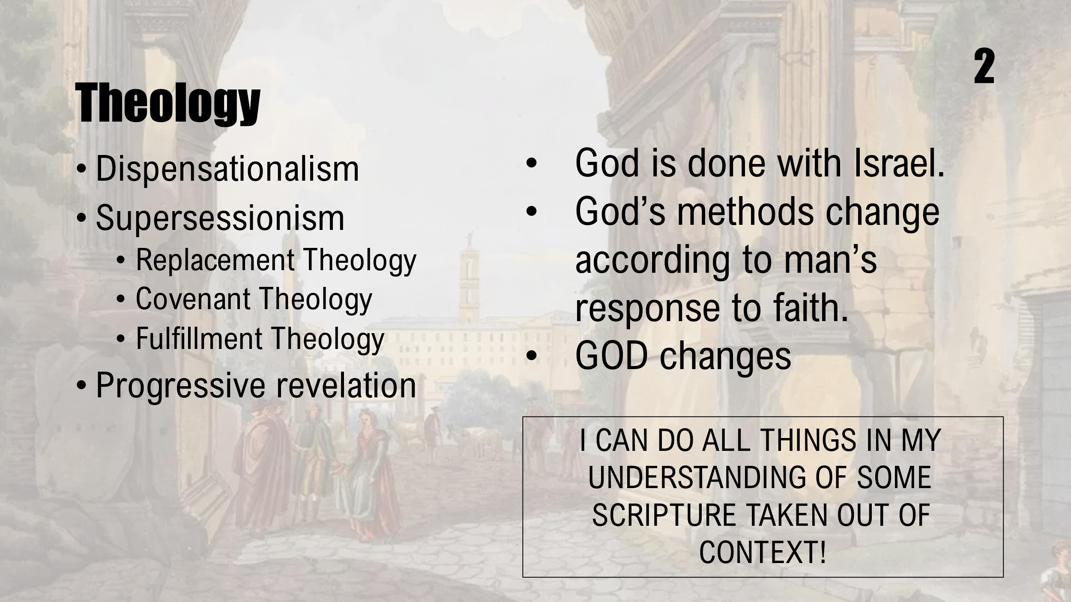
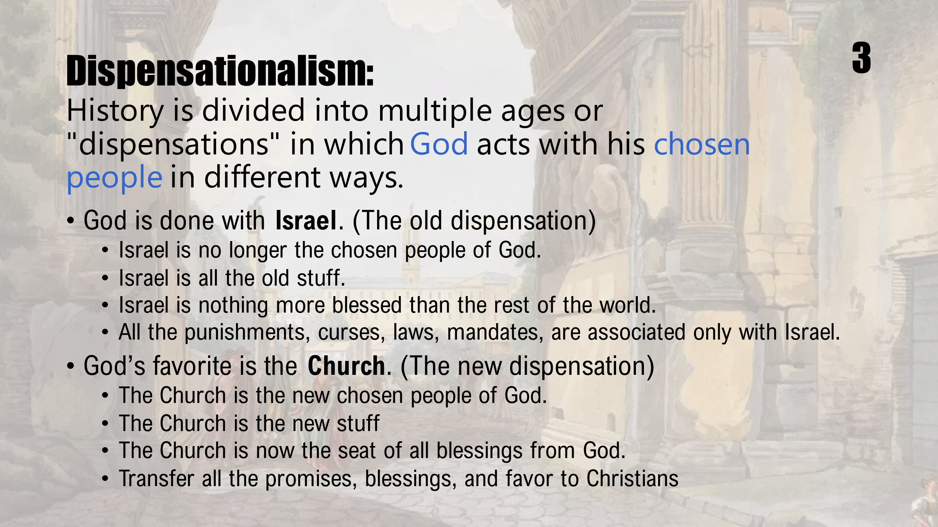

To better understand the future of Israel as explained by Paul, we are going to break chapter 11 into three sessions:
- December 6th - Romans 11:1-6. The absolute certainty of Israel in the future God is not done with Israel.
- December 13th - Romans 11:7-24 What God has planed for Isreal
- December 20th - Romans 11:25-32 What is Israel’s prophetic future.
In January we will study the beginning of the practical implications of salvation in Chapters 12, 13,14,15,16.

Romans 11:1-2a - Paul the great example

I say then, God has not rejected His people, has He? Far from it! For I too am an Israelite, a descendant of Abraham, of the tribe of Benjamin. God has not rejected His people whom He foreknew.
Since the death and resurrection of Jesus, a period of 1990 years, millions of Jews have found grace and peace in Jesus by faith. They are the fulfillment of the promise given to Abraham. Today in the United States, there are about 1.6 million Christian Jews. Here Paul uses himself as an example of one of the Chosen People clear pieces of evidence that God has not set aside the Jews.
God has not and will not ever reject the Jews.
They were set apart for a divine purpose, for a divine destiny to bring the world to one God. To this end, their destiny was to bring:
- Monotheism - the belief there is one God,
- To receive the Law of God as given to chosen men and women.
- They can have an individual and personal relationship with God
- They believe God continues to work in the world affecting everything people do.
- To be the womb of the Messiah,
- A belief that God rewards good deeds and punishes evil
- They are a people of promise and covenant,
- They are to be an example ethical living.
The Jews of Paul’s time were never excluded from grace. God used them the change the world. God’s perfect plan has included and will always include the Jews a people. This plan may or may not include the nation or some political drawn lines. You may call them the “elect” or “foreknown”, but their existence as a people was destined.

Illustration
I was a project manager for a number of years. There was a prescribed method of determining the length of a project. After listing all the tasks that would be needed to accomplish the project, they were given dependances. An example of dependances is that you can’t put on the floor of a house if you have not poured the foundation, so a floor had a dependency on a foundation. After putting them all in order. All the tasks had a length of effort, or how long it would take to accomplish the task. If you added all the dependent tasks in a Finish Start relationship it would determine the critical path or how long the whole project would take. Therefore, if any single task was delayed or took longer to accomplish the total time of the project would be moved at the same time. NOT A GOOD THING.
The chosen people of the Old Testament were on the critical path. When they delayed something in their path the time to accomplish God’s destiny was expanded. God had made the project plan. He knew the finished product. It was destiny. It was foreknown. The problem was most of the tasks assigned to the resources assigned to the tasks kept changing the timeline. It did not affect the projected result; it just changed the length of the plan.
Paul became a part of the plan to bring the world including the Jews to God. But there were those who were saying throw out the Jews. They are yesterday’s news. They were not part of the plan anymore. But to say the Jews were rejected, set aside, removed from the perfect plan of God, then Paul is out in the cold with them.
Paul was walking a tight rope. Between the Jews who were the majority in the Roman church and the ever-growing number of Gentiles. He was showing to the whole church, Jews and Gentiles together were part of the plan. And Paul was showing both sides the necessity of the other. Paul was an example of Grace offered to the Jew. Paul though once a persecutor of the Christians, who once was struck blind on his zealous project of destroying the Christians, who finally listened to the risen Jesus, who finally found the Messiah of his life, was the Paul that was saved by grace and found peace.

Romans 11:2b-5 – Example of Elijah

Or do you not know what the Scripture says in the passage about Elijah, how he pleads with God against Israel?

“Lord, THEY HAVE KILLED YOUR PROPHETS, THEY HAVE TORN DOWN YOUR ALTARS, AND I ALONE AM LEFT, AND THEY ARE SEEKING MY LIFE.”

But what is the divine response to him? “I HAVE KEPT for Myself SEVEN THOUSAND MEN WHO HAVE NOT BOWED THE KNEE TO BAAL.”

In the same way then, there has also come to be at the present time a remnant according to God’s gracious choice.

Israel was not the last chapter in God’s project Plan for the Jews. Jesus was not a heavenly reset of his plan. God did not change His mind and change his tactics. His original plan was for faith and grace. This faith and grace was revealed back in the times of old.
Paul brings up the example of faith and grace from the life of Elijah. Paul’s reference to Elijah would be very familiar to the Jews in the Roman church.
Elijah was a prophet in 1 Kings. Elijah was a mighty man of God and is quoted here by Paul. It was a low time for the prophet. Elijah is in prayer. “LORD, ONLY I AM LEFT, ALL MY PEERS THE PROPHETS OF THE ISRAEL AND JUDAH WERE DEAD, THE OPPRESSORS HAVE TORN DOWN EVERY ALTAR, MONUMENT, EVERY PLACE OF WORSHIP, AND NOW I AM BEING CHASED AFTER TO JOIN THEIR FATE.”
History here. Elijah as a prophet in a land filled with another religion: one that worshiped BAAL the God of Asherah. The Asherah group was most powerful because the Queen to King Ahab, Jezebel, was a part of that group. Jezebel called Elijah a troublemaker. Elijah challenged the status quo.
Bring on your prophets of BAAL and ASHERAH and we will have a once and for all challenge. Two altars with two bulls set up to sacrifice to their respective Gods. After much shouting and marching the first group failed miserably. (I Kings 18:16-30). Elijah had a new altar made of 12 stones and placed the bulls on the altar. He had this grand heap doused with water three times and then he prayed. The fire from on heaven high fell and burned it all: stones, sacrifice, wood, soil. V36-38. He had all the prophets of BAAL brought to a nearby valley and killed them all. Afterwards Jezabel was out to get him. He went to a cave in Horeb where he hid.
Elijah thought he was the only one left to proclaim God. Elijah was being hunted down to be killed by Jezebel and King Ahab. He saw himself in an position that had no solution.
Here God responds to Elijah’s cries for mercy as quoted by Paul. V2. There have been times in my life where I think God is way off. But He is not.
God seems to work with a portion, a remnant. As God revealed to Elijah there were always be a group that will continue on.

Issues with Elijah and me
I can easily understand the feelings and cries of desperation Elijah. We all have limited knowledge. We don’t see all that is going on around us. God’s perfect plan is still moving forward. Elijah may not have been on the critical path toward human salvation but is part of the plan. God’s plan was till perfect. To Elijah and I, we only see ourselves. And we cry out. Am I the only one? Are you the only one?
What God revealed to Elijah was there are more out there struggling just as he was. There were 7,000 more.

Jewish rabbis have as part of their theology an explanation between the Jewish thought and Christian thought. In this scholarly work it describes the differences between Christianity and Judaism.
One rabbi writes about Paul:
Paul claimed that obedience to the Torah (the Law) could not guarantee salvation; rather, salvation was obtainable only through acceptance of and faith in Christ Jesus. To believe that a person could atone for his own sinful condition through any efforts on his own, as, for example, by obeying the laws of the Torah, was accordingly a delusion. But Paul eagerly announced that what man could not himself accomplish, namely salvation, could still be accomplished for him. Only God, however, was powerful enough to atone for man's sinfulness, and Paul held that the death of Christ Jesus was that act of divine atonement.
Then this Rabbi professor adds,
We Jews have rejected this Gentile Christian view. Judaism, as shaped by our rabbis in Palestine, conceived of the body as a gift of God, and to this day we regard the body as holy and wholesome, not as a prison from which to escape. Any inclination by man to commit a wrongdoing, we hold, resides not in his body but in his heart or mind. And this inclination can be overcome by a change of heart or mind. Thus man, by himself, does indeed possess the power to atone for his own misdeeds, and we Jews have, in our Torah, the guidance directing our hearts and minds to righteous living.
On that basis, the Jews say:
They can win their way to acceptance before God without dealing with the sin problem and without ever taking into consideration the full teaching of the Scriptures. Paul says, therefore, that many have been rejected because of that.

There are three ideas to be accepted based upon this scripture:
- That it is no unparalleled thing for the love of many to wax cold, and for iniquity to abound.
- the tendency of this is to produce deep feeling and solicitude among the true friends of God. Thus, David says, "Rivers of waters run down mine eyes because they keep not thy law;" Psalm 119:136; compare Jeremiah 9:1; Luke 19:41.
- that in these darkest times we should not be discouraged. There may be much more true piety in the world than in our despondency we may suppose. We should take courage in God, and believe that he will not forsake any that are his true friends, or on whom he has purposed to bestow eternal life.
- it is of God that all are not corrupt and lost. It is owing only to the election of grace, to his merciful choosing, that any are saved. And as in the darkest times he has reserved a people to himself, so we should believe that he will still meet abounding evil, and save those whom he has chosen from eternal death.

Romans 11:6

But if it is by grace, it is no longer on the basis of works, since otherwise grace is no longer grace.
With the example of the remnant of the Jews who had embraced faith, Paul gives reasons that the Jewish their standing in the Christian church had no relation to or dependence upon their past or present observance of the law of Moses.
Their standing in the church and covenant of God was according to the election of grace; grace, received by faith, was the only ground upon which they stood, and had a title to the privileges of God's people.
The election of grace is not a particular act of sovereign grace reserved for a chosen few. Here about the 7,000 which stayed faithful were not pre-ordained to be saved and the rest cast off. The remnant of the Jews were part of the plan. It was no act of special favor, a choice of specialness but by their purposeful choice.
Paul was reminding the entire Church in Rome of the equal decisions and acceptances of who have accepted of the grace of the Gospel, and are the people of God, after the only true way of choosing his people, which is by grace.
Here in the Book written to the entirety of the Church in Rome. This remnant of Jews who were a part of the Church did not claim their standing in the church as just covenant but by grace and faith. Their faith not based upon their observance of the law of Moses; for if it were, grace would lose its proper nature and cease to be what it is; a free undeserved gift. On the other hand, were it true that they are invested in the privileges of the kingdom of Christ by the observance of the law of Moses, then grace would be quite set aside; for if it were not, work, or the merit of obedience, would lose its proper nature, which excludes favor and free gift." See Locke and Doddridge.

NOTE OF STUDY METHODOLOGY
In this age of being politically correct and not using words that would offend, it is difficult to use a single word to describe an ethnic group. The term “Jew” is not inherently derogatory, but it has been used as a slur in the past. According to an article by WNYC Studios, the term “Jewish” is now considered the preferable and safer term to use. However, the same article also notes that some Jews use the term “Jew” to describe themselves without any negative connotations.
In the past, the term “Hebrew” was used as a socially acceptable or politically correct term for Jews. However, this term is now considered outdated and is not commonly used.
Here is a list of titles this group:
Jew | Common term used today and is not offensive. It speaks of a people
Jewish | It seems like this is name Jew, just softened
Israelite | This is used as a global term but not entirely correct that in the bible it is used to describe a people from the Northern Kingdom
Seed of Abraham | A term which gives the common ancestry.
Chosen People | A designation of a people that were chosen in God’s perfect plan to bring mono-theism to the world
Hebrew | An outdated term which speaks of a people of a common language.
Judaism | A religion attached to the Southern Kingdom and its related ceremonies and sacrifices. This title is also used to describe a belief structure.

In this study I use these terms interchangeably.

