Paul’s Letter to the Roman Church

Week 19: What are we meant to be? Romans 7:13-25
Lead by: Just Larry—916-337-2648 — ljmonson@hotmail.com—http://theoinsight.com/romans

NOTES: ___________________________________________________________

________________________________________________________________

________________________________________________________________

________________________________________________________________

________________________________________________________________

________________________________________________________________

________________________________________________________________

________________________________________________________________

________________________________________________________________

________________________________________________________________

________________________________________________________________

________________________________________________________________

________________________________________________________________

________________________________________________________________

_____________________________________________________________________________________

________________________________________________________________

________________________________________________________________

Memory Verse: Romans 8:1 There is therefore now no condemnation for those who are in Christ Jesus.

Romans 7:14-25

Synopsis:
Romans 7:13-24 contains a complex and highly debated passage in which the Apostle Paul describes his struggle with sin and his inability to do what he knows is right.
There are four schools of thought on this portion of scripture: Jewish struggle, personal struggle with a physical malady, Paul dealing with real sin in his life along with an inability to overcome them, and a universal struggle. It must be remembered this portion is very personal to Paul and must be seen through his soul-searching.
- The first interpretation is the unique struggle a converted Jew has with trying to reconcile his Jewish ethnicity, culture, and Hebrew responses to the law. The Law exposes sin based upon expressed law, a law that was expressly for the Nation of Israel and no one else. This view is of Paul before his encounter with Jesus on the Road to Damascus. The 613 laws, commands, and ceremonies seem to have created a higher standard for him and those he calls brothers. In the life of Paul this is viewed through a Jewish window and the view is a mountain too high to scale. He continually falls short.
- The second view is a picture of Paul’s struggle with what is pointed out in another writing as his “thorn in the flesh”. He says that he knows what is right, but he finds himself doing what is wrong instead. He describes a constant battle within himself between his desire to do good and his tendency to give in to sin. He says that he does not understand why he does what he hates and why he cannot do what he knows is right. This terrible situation is caused by a flaw in his flesh which haunts him day and night.
- Thirdly, there is the interpretation that this passage is Paul's description of the human condition in general. They argue that Paul is describing the universal human experience of struggling with the desire to do what is right and the temptation to do what is wrong. They suggest that Paul is acknowledging that, even after we become Christians, we will still struggle with sin and will need to rely on God's grace and the power of the Holy Spirit to help us overcome it.
- Lastly, some scholars interpret this passage as Paul's description of his struggle with sin. They argue that Paul is describing his own experience of the tension between his desire to follow God and his human limitations. They suggest that Paul is acknowledging the reality that even as a Christian, he is not perfect and still struggles with sin. He comments on something within him that is simply in charge, and he is not in control.
Regardless of the interpretation, the passage highlights the tension that exists between our desire to do what is right and our tendency to give in to sin. It also emphasizes the importance of relying on God's grace and the power of the Holy Spirit to help us overcome our weaknesses and live a life that is pleasing to God.

Greek understanding of specific words

MANKIND - Anthropos – Man in totality
All inclusive pronoun to refer to all human beings, it is used to describe Adam up to Genesis 2:18. In Paul’s time it was simply all humankind. It I found in our scripture tonight in 7:22 speaking of the old man a common characteristic of the species and 7:24 referring to wretched man as one of many.

SPIRIT – PSYCHE – GOD consciousness
Psyche – Person, life, self, soul. It is what I see when I look deeply into myself and see my moral image of God. A seat of my senses, desires, affections, appetites, prejudices, predilections, and feelings, it directly affects the emotion. The human spirit is the deepest part of a person. By means of this innermost part, we can contact God in the spiritual realm. No other creature was created by God with this part. First in the life of Paul and his theology is the spiritual nature. We are spiritual beings living in an earthly existence. Greek philosophy would say It is the fire that burns or delights depending upon my SARX.

BODY – World Consciousness-
In the language of the time there were two words use to describe the human body. SARX and SOMA. You may well say that the idea of SARX is inside the idea of SOMA.

Sarx – Flesh as to a physical body
This is principally because of the range of usage since it seems to span from the innocuous sense of the physical material of the body to the sense of "flesh" as a force hostile to God. When Paul uses it is almost always seen as a negative. In our scripture for tonight, it is found in 7:14 as a description of his body. SARX is only used in referring to feebleness and liability of death. And is only used in the context of our world and therefore temporary.

Soma – Body as to the totality of the body's experience.
Soma as denoting the human body includes the physical body but is more than that. A better word to use — it would also help us break away from our twentieth-century preconceptions — is the alternative term "embodiment" — soma as the embodiment of the person. In this sense, soma is a relational concept. It denotes the person embodied in a particular environment. It is the means by which the person relates to that environment, and vice versa. It is the means of living in, of experiencing the environment. Soma as embodiment means more than my physical body: it is the embodied " m e , " the means by which " I " and the world can act upon each other clearly. For Paul the soma body is never seen as either good or bad but simply a part of our interactions with the physical.

SOUL – Self-consciousness
Our soul perceives things in the psychological realm. Our soul is our personality, who we are. Paul the soul had two uses in Romans as Nous and Kardia. I am therefore I think, and I am therefore I am emotional.

NOUS – the intellectual soul
The thinking and rational part of our lives. It is found 15 times in Romans. And includes the meanings of mind, highest part of reason, rational thought, that which we react to the stimuli of things about us. Romans 7:22, 25 includes these ideas and words.

Kardia – the emotional side of our life
It is used in Romans six times. It is the word we think of as our heart. It is the part of our lives that thinks emotionally. We experience emotions like happiness, love, sorrow, anger, relief and compassion.
With these ideas and words in mind what changes when we are justified?
Does the body either Sarx or Soma change at justification?
Does the soul either intellectually or emotionally change at justification?
Does the Spirit change at justification?

Phrase analysis
- For we know that the Law is spiritual,
  - but I am of flesh,
  - sold into bondage to sin.
- For what I am doing, I do not understand;
  - for I am not practicing what I would like to do, but I am doing the very thing I hate.
  - But if I do the very thing I do not want to do,
    - I agree with the Law,
    - confessing that the Law is good.
  - So now, no longer am I the one doing it, but sin which dwells in me.
- For I know that nothing good dwells in me, that is, in my flesh;
  - for the willing is present in me,
  - but the doing of the good is not.
  - For the good that I want,
    - I do not do,
    - but I practice the very evil that I do not want.
  - But if I am doing the very thing I do not want,
    - I am no longer the one doing it,
    - but sin which dwells in me.
  - I find then the principle
    - that evil is present in me,
    - the one who wants to do good.
- For I joyfully concur
  - with the law of God in the inner man,
  - but I see a different law in the members of my body,
    - waging war against the law of my mind
    - and making me a prisoner of the law of sin which is in my members.
- Wretched man that I am!
  - Who will set me free from the body of this death?
  - Thanks be to God through Jesus Christ our Lord!
- So then,
  - on the one hand I myself with my mind am serving the law of God,
  - but on the other, with my flesh the law of sin.

Commentary and Exposition

Four observations to start in our study:
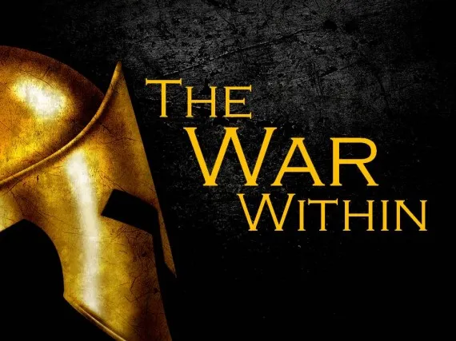
I would like to begin with FOUR observations about this famous text. Observation number one is this:
- Romans 7 is a passage that grips us because we understand exactly what it is saying. We see ourselves in it. When Romans 7 is read everyone understands and says, “Amen, yes, that’s right, that’s true, that’s me.” We either have been there or are right there now.
- Observation number two: Romans 7 tells us about the Christian life as we experience it much of the time. Paul is not discussing the life of an unbeliever. Nor is he describing an immature or carnal Christian. In my opinion, This portion of Romans 7 is describing the Christian life as it is experienced sometimes by the people of God.
Now to say this is to enter into a huge theological debate that has raged across the centuries. These are my conclusions because, to be honest, it is a picture of me. This lesson tonight is my testimony. This lesson tonight is, if you are honest and open, is your life.
The conclusions I bring to you tonight are mine. I bring you my thoughts and what has helped me in my War within.
When I read the portion of scripture, I think that what you have here in the latter part of Romans 7 is Paul’s spiritual autobiography of his experience as a follower of Jesus Christ. When I read this, I think that what you have here in the latter part of Romans 7 is Larry’s spiritual autobiography of his experience as a follower of Jesus Christ.
You read the text and Paul constantly says “I … I … I … I.” And it’s not past tense. It’s present tense. Paul has taken a grand detour from theology to practice. It is Paul’s experience of the Christian life as he lives it day after day after day after day.
- That leads me to a third observation.
If you relate to Paul and me, in our Christian life, one of the first things that come to light is your struggle, and the second that we would like to say this testimony of our life simply doesn’t exist. We would rather keep it stuffed into the dark reaches of our lives. To keep a happy face and when someone asks, “How is your soul today” we immediately respond with “FINE”.
But none of us are FINE. The third observation is there is no escape. There is a war going on. And we are in it.
There is no real escape.
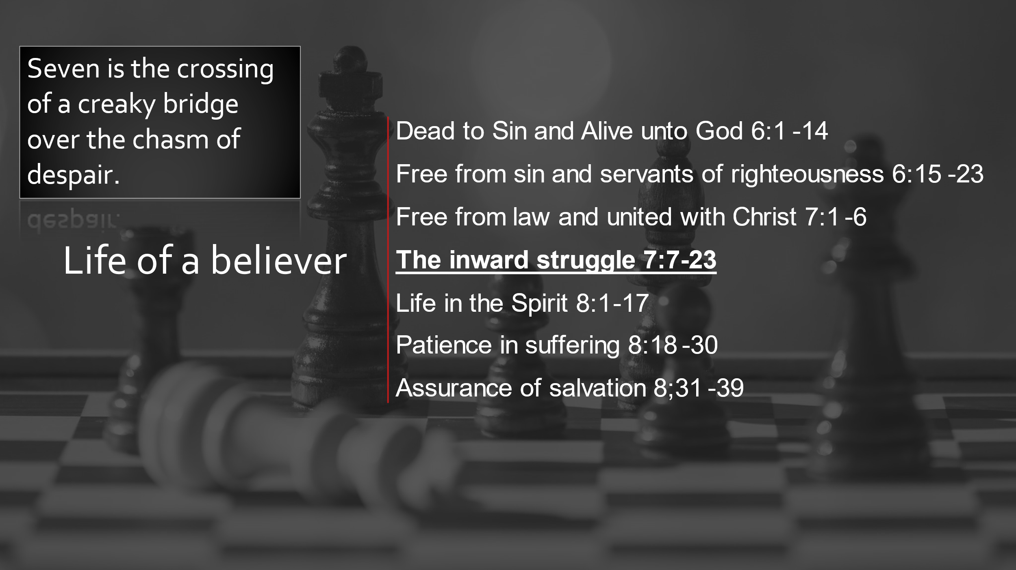
- Lastly, the fourth observation is that as we warriors of the faith try to understand Romans 7:14-25, IT IS NOT THE WHOLE STORY OF SPIRITUAL LIFE. This text is not in isolation. It is wedged between two others. There is a reason for Paul to open his heart and bear it all. There is a reason for the acknowledgment of the war within
The fourth conclusion there is an answer to the War. I would say it like this: Romans 7 is not the whole story but it is a part of the story.

I would surmise that it is a significant part of the Christian experience for every follower of Jesus Christ.
Some would argue otherwise. Some say this is nothing more than a flight of fancy included here to tell the Church of Rome that it was a story of his Jewish life before Christ.
Others would say that Paul’s experience describes a “sub-normal” Christian life in Romans 7.
Others would say we should not take notice of 7 and move on quickly to Chapter 8. Eight is the victory, eight is the key to a great perfect life. Maybe so but I have to deal with the seventh chapter first. If you are there struggling with Paul in his WAR WITHIN, we cannot simply ignore it. To forget it ever happened.
This part of Romans is a part of the whole of the Christian life.
- THERE IS NO HINT THAT THE STRUGGLE WITHIN IS A MOMENTARY PHASE THAT WE CAN GET OVER.
- PAUL WAS SAYING CHAPTER 6 IS IMPORTANT
- PAUL WAS SAYING CHAPTER 7 IS IMPORTANT
- PAUL WAS SAYING CHAPTER 8 IS IMPORTANT
- THEY ARE ALL PARTS OF THE LIFE OF THE CHRISTIAN
Further If you are to live this life as a Christian you cannot skip Romans 7:14-25. The experience that Paul is talking about here is a necessary part of your walk with Jesus Christ. God put these verses in the Bible for your blessing. He put them in the Bible because they reflect a part of life that all of us experience but rarely talk about when we come to church on Sunday morning.
This section may be condensed into one word. STRUGGLE. Or maybe CONFLICT. Or even WAR.

Struggle, conflict, and war.
Whom are we struggling with? ______________________________________________________________
You’re going to have a struggle, you’re going to have a conflict, you’re going to experience inner warfare. Paul says in this passage that the problem is not sin on the outside, but the problem we have to face is sin on the inside. The problem is not simply temptation “out there” but temptation “in here.” For all of us as believers in Jesus Christ, sin is not something that simply is outside of us, but clearly, Paul is saying that sin is something that we must wrestle with on the inside every single day.

“We have met the enemy and he is us.”
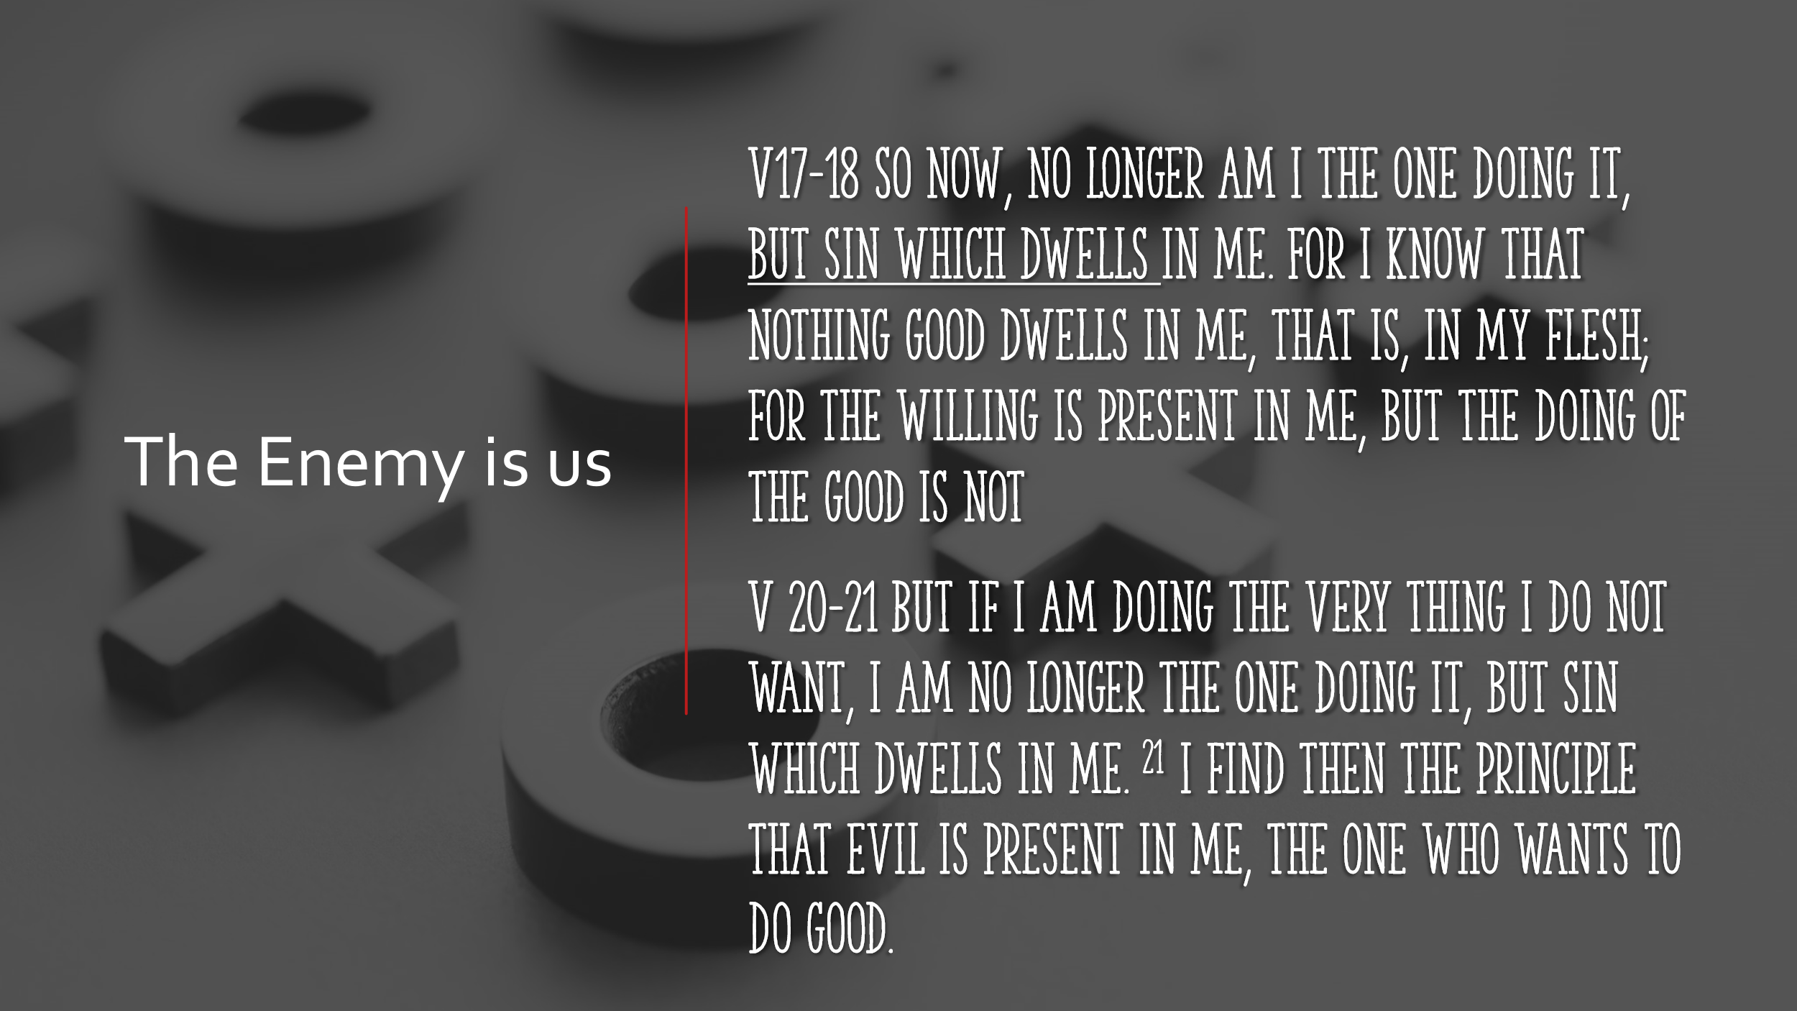
Paul stops and looks deeply into his soul and sees it. We have met the enemy. The enemy is us.
The enemy is not just out there somewhere. The enemy is on the inside. He has infiltrated into our very being.

Illustration
I preached a simple message from the pulpit at LT. a year ago or so. It wasn’t much by the standards of hermeneutics and homiletics. I worked hard on it. It had good visuals. It had all the requisite points.
It even had a pretty good conclusion, calling for change. But I was disturbed to the core when I was walking off the platform, there was applause. On the inside, there was a violent response of, “Oh, wait a minute. If you knew the way I am, you wouldn’t be clapping. You wouldn’t be saying “Good JOB.” The moment of true appreciation was spoiled by an inner something that told me, “You are not worthy.”
Why is it that there is this struggle inside every believer?

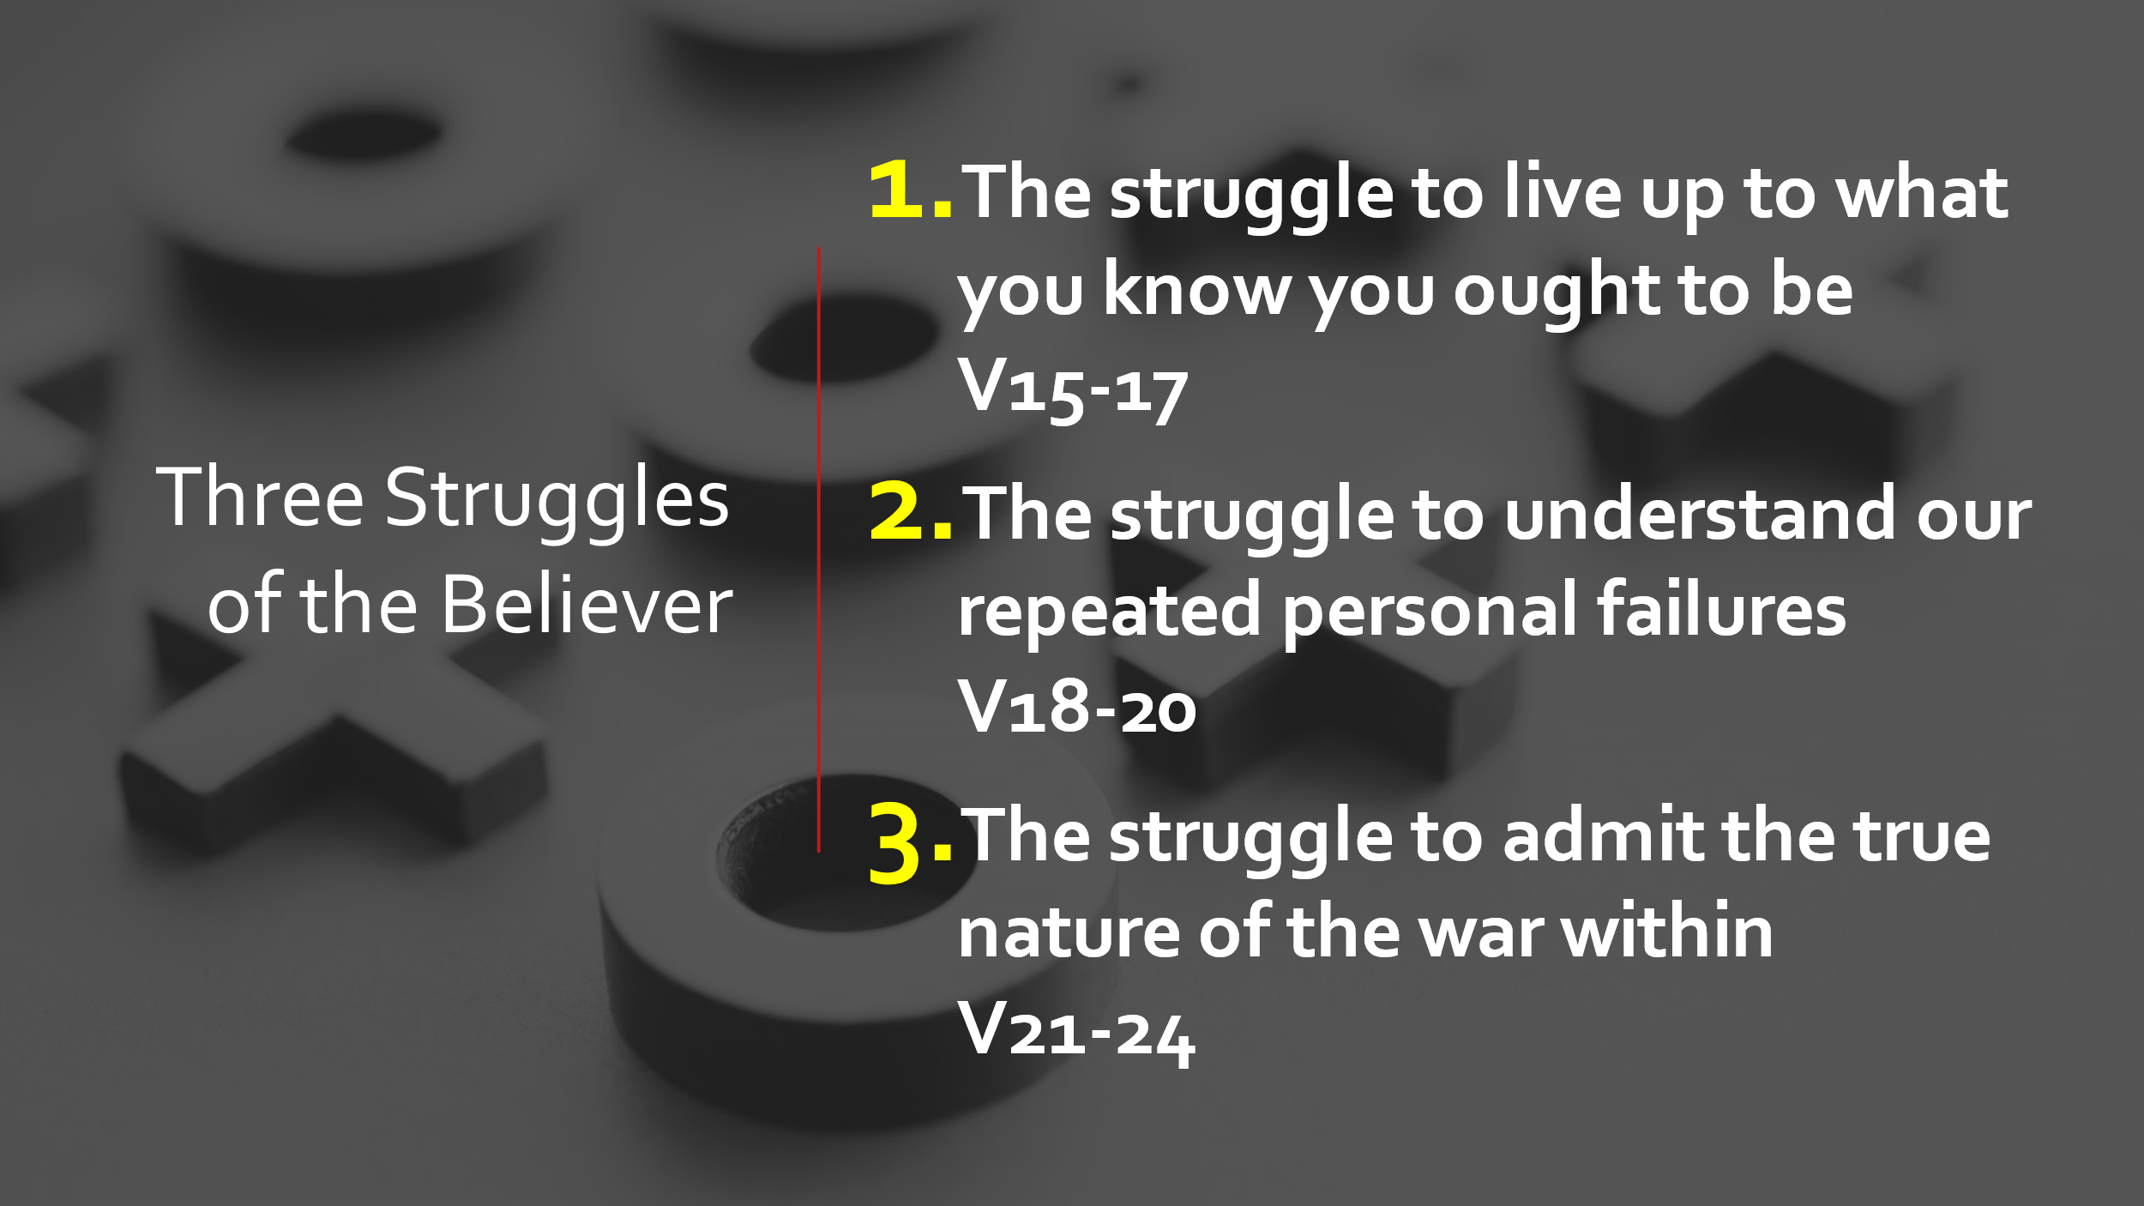
The answer is very simple and it is two words. The answer is indwelling sin. Look at the text. Paul says it twice very plainly. In verse 17, “as it is it is no longer I myself doing it, but it is sin living in me.” Sin living in me. He uses the same phrase in verse 20– “sin living in me.”
Sin dwells inside the life of every believer. Paul says that sin is actually present in the members of his body.
REMEMBER this is after Justification in Chapter 4,5,6. This is after becoming slaves to righteousness. This is after becoming joined with Jesus. Yet Paul states plainly and forthrightly, “When I would do good, evil is right there with me.”
As long as you are a follower of Jesus Christ, you will never be completely free from the pull of the sin that is inside you. As long as you are in your mortal bodies, you will wrestle with sin.
In verse 24, Paul cries out in desperation, “What a wretched man I am! Who will rescue me from this body of death?” Have you ever thought about the fact that sin is the reason your body grows old? Sin is the reason your body decays, sin is the reason your body dies. It is in this corruptible body is a sin principle working inside. In this passage, Paul lays bare the struggle between the liberated mind which knows Jesus Christ and the indwelling principle of sin in the body of the believer.
What Paul is saying is that there is a war that is going on inside the heart of everybody who follows Jesus Christ. A struggle, a war, and a conflict that goes on 24 hours a day, 7 days a week, 52 weeks a year, year in and year out. Nobody ever comes to a place where he can say, “No, I don’t struggle anymore. No, the war is over for me.” If you’re a believer, that will always be true of your experience to one degree or another. As long as you live, the struggle is going to go on.

The struggle to live up to what you know you ought to be V15-17
That’s an amazing confession. I have done some dumb things in my life. There are times in all of our lives we have done something stupid. When somebody asks us why did we do that, the only answer we can come up with is, “I don’t know why I did that.”
I DO NOT UNDERSTAND WHY I DID THAT. We all have what is called our guilty pleasure. As simple as eating a whole bag of Oreos in one sitting and taking the empty bag out to the garbage so the evidence would not be found. Or as complex as lying to your employer on your resume. And in the end we say “I don’t understand why I did that”. Why did just didn’t do what was asked of me even after I promised to do it? Why did you sign that lease? Why did you make that deal? Why did you break that promise? The only answer you can come up with is, “I don’t really know why I did that. Something just moved within me and I did it and I don’t really understand it.”
You are in good company because that’s what the apostle Paul said. He said, “Many times I do things and afterward I don’t understand why I did them.” It is a confession: “For what I want to do, I do not do. But what I hate, I do.”

The struggle to understand our repeated personal failures V18-20
Paul is here confessing the struggle within his soul. He is saying that he feels like a split personality. He feels that there is a continual civil war going on inside his heart. It’s almost as if he feels two people inside him or as if he hears two voices, one calling him this way and one calling him that way, and he says, “I want to do good, but I don’t do it. “But the thing that I don’t want to do, I do anyway.”
William Barclay entitles his commentary on this passage The Human Situation.
This is truly the human situation. We know the good, but we don’t do it. We know what’s wrong and we fight against it and then we do it anyway. We say “I will” and then we don’t. We say “I won’t” and then we do. We make a promise and then we break it. We set a goal and we don’t go after it.
And the guilt afterward: We say “I’ll never do that again” and we do it. We get on our knees and say, “Oh, God, I’ll never do that again.” And then the next day, we do it or we say it again. That is the true human experience for all of us.
If anybody here says that’s not true of you, let me tell you something. I simply will not believe you. I simply will not believe you because that is the human experience for you and it is the human experience for me.
Knowing and doing are two different things. You can know the right thing and you can still do the wrong thing. Nothing is stopping you. Knowledge will never save anyone. Knowledge alone will not save us. There must be something else, something deeper working within us. That leads me to make this conclusion. Even if you are a follower of Jesus Christ, you’re not as good as you think you are, and you’re worse than you’d like to admit. That’s the first struggle. The struggle to live up to what you know you ought to be. “The evil I do not want to do–this I keep on doing.”
Remember again this is the spiritual giant named Paul who was saying this as an apostle and as a follower of Jesus Christ. If you’re a follower of Jesus Christ, you can understand these words. They’ll make sense to you. If these words don’t make any sense to you at all, it may be because you’ve never come to Jesus Christ at all. After all, those who are truly born of God develop in their heart a deep and honest, and holy hatred of sin.
It has been said, “that the closer you come to God, the less you will sin and the more of a sinner you will realize yourself to be”.
Thank God when you come close to God, you will sin less … and the greater will be your understanding of how deeply sinful you have been and you now are. There is little I have not heard in my role as a pastor. Little surprises me anymore. The degradation and terrible things people do, do not overwhelm me as much as it did when I was afresh with the glow of college.
If there is one constant in all the encounters with fellow Christians is that the human condition is not perfect. I am well aware of scripture and the human condition confirms it all:
Romans 3:10, “There is no one who does good, no, not one.”
Romans 3:23, “For all have sinned and come short of the glory of God.”
Romans 6:23, “The wages of sin is death.”
Numbers 32:23, “Be sure your sin will find you out.”
Jeremiah 17:9, “The heart is deceitful above all things and desperately wicked. Who can know it?”
Proverbs 28:13, “He who covers his sin will not prosper but he who confesses and forsakes it will find mercy.”
1 John 1:7, “The blood of Jesus Christ, God’s son, cleanses us from every sin.”
1 John 1:9, “If we confess our sins, he is faithful and just to forgive our sins and to cleanse us from all unrighteousness.”
You don’t have to convince me of the reality of indwelling sin; it is in the lives of believers of this church and in my own life, because I see too much and I hear too much and I experience too much. When I stand in front of the mirror what I see is a man who struggles with sin every single day.
We try to come up with spiritual formulas to convince it is not so. But it is still there. That flesh (SARX) keeps us back. It causes us to sin and sin repeatedly. We all must admit it. We must come to grips with repeated personal failures. Healthy people do not need doctors. Sick people do.

The struggle to admit the true nature of the war within V21-24
The phrase “EVIL is PRESENT IN ME” means right beside me. It means I am here and evil is glued to my side. It means I’m joined with sin as to a Siamese twin. Everywhere I go, evil goes with me. Even when I want to do good, all I have to do is reach out my hand and I can touch evil. It’s right there beside me.
- We are not in a war with temptation.
- We are not in a war with our culture.
- We are not in a war with society screaming at us to be more like them.
Then he uses military terms to describe the struggle–” waging war”, and “making me a prisoner.” The war we fight is all in line, marching us toward death and pain. There is evil in us as long as we walk this earth. Evil is not only with us, evil is also waging war inside of us all the time. There’s no amount of going to church that is going to change that fact. There are no twelve-step programs that will free you from sin forever.
When I read Romans 7 and I see a godly man admitting the truth about the struggle within his soul. If Paul struggled, it will probably happen to me and you too.
We’re going to struggle. The real battles are not the ones on the outside. The real battle of sin is the one on the inside. It’s the one that nobody else ever sees. It’s the struggle that goes on in your mind and your heart, between the pull of the flesh and the pull of the Holy Spirit.
We are good looking bunch here tonight. We are here in our places with bright shiny faces. Behind your smiles and jokes, there is a story of struggle, conflict, and war. Behind your solid human exteriors is heartache, despair, defeat, victory, cowardice, bravery, fear, and courage, ALL mixed.
Some of you struggle to get up in the morning, facing the day with resolve and hope. You put on a good face.
I am a man. I am a manly man. I can handle anything. But it is too easy to y I look good, you look good. I have no problems, You don’t have any problems. But in reality, we are all walking wounded.
There is no victory in Chapter 8 without war in the 7th.

Three steps, or ideas to help us get to Chapter 8
These are the first steps to understanding the rest of the book

Honesty 24a
This is a Christian man saying “You know the truth, and the truth will set you free. But it will hurt you first.”
The lack of growth in many Christians is because we hear the truth in our minds. We don’t let it come so close as to inflict pain.
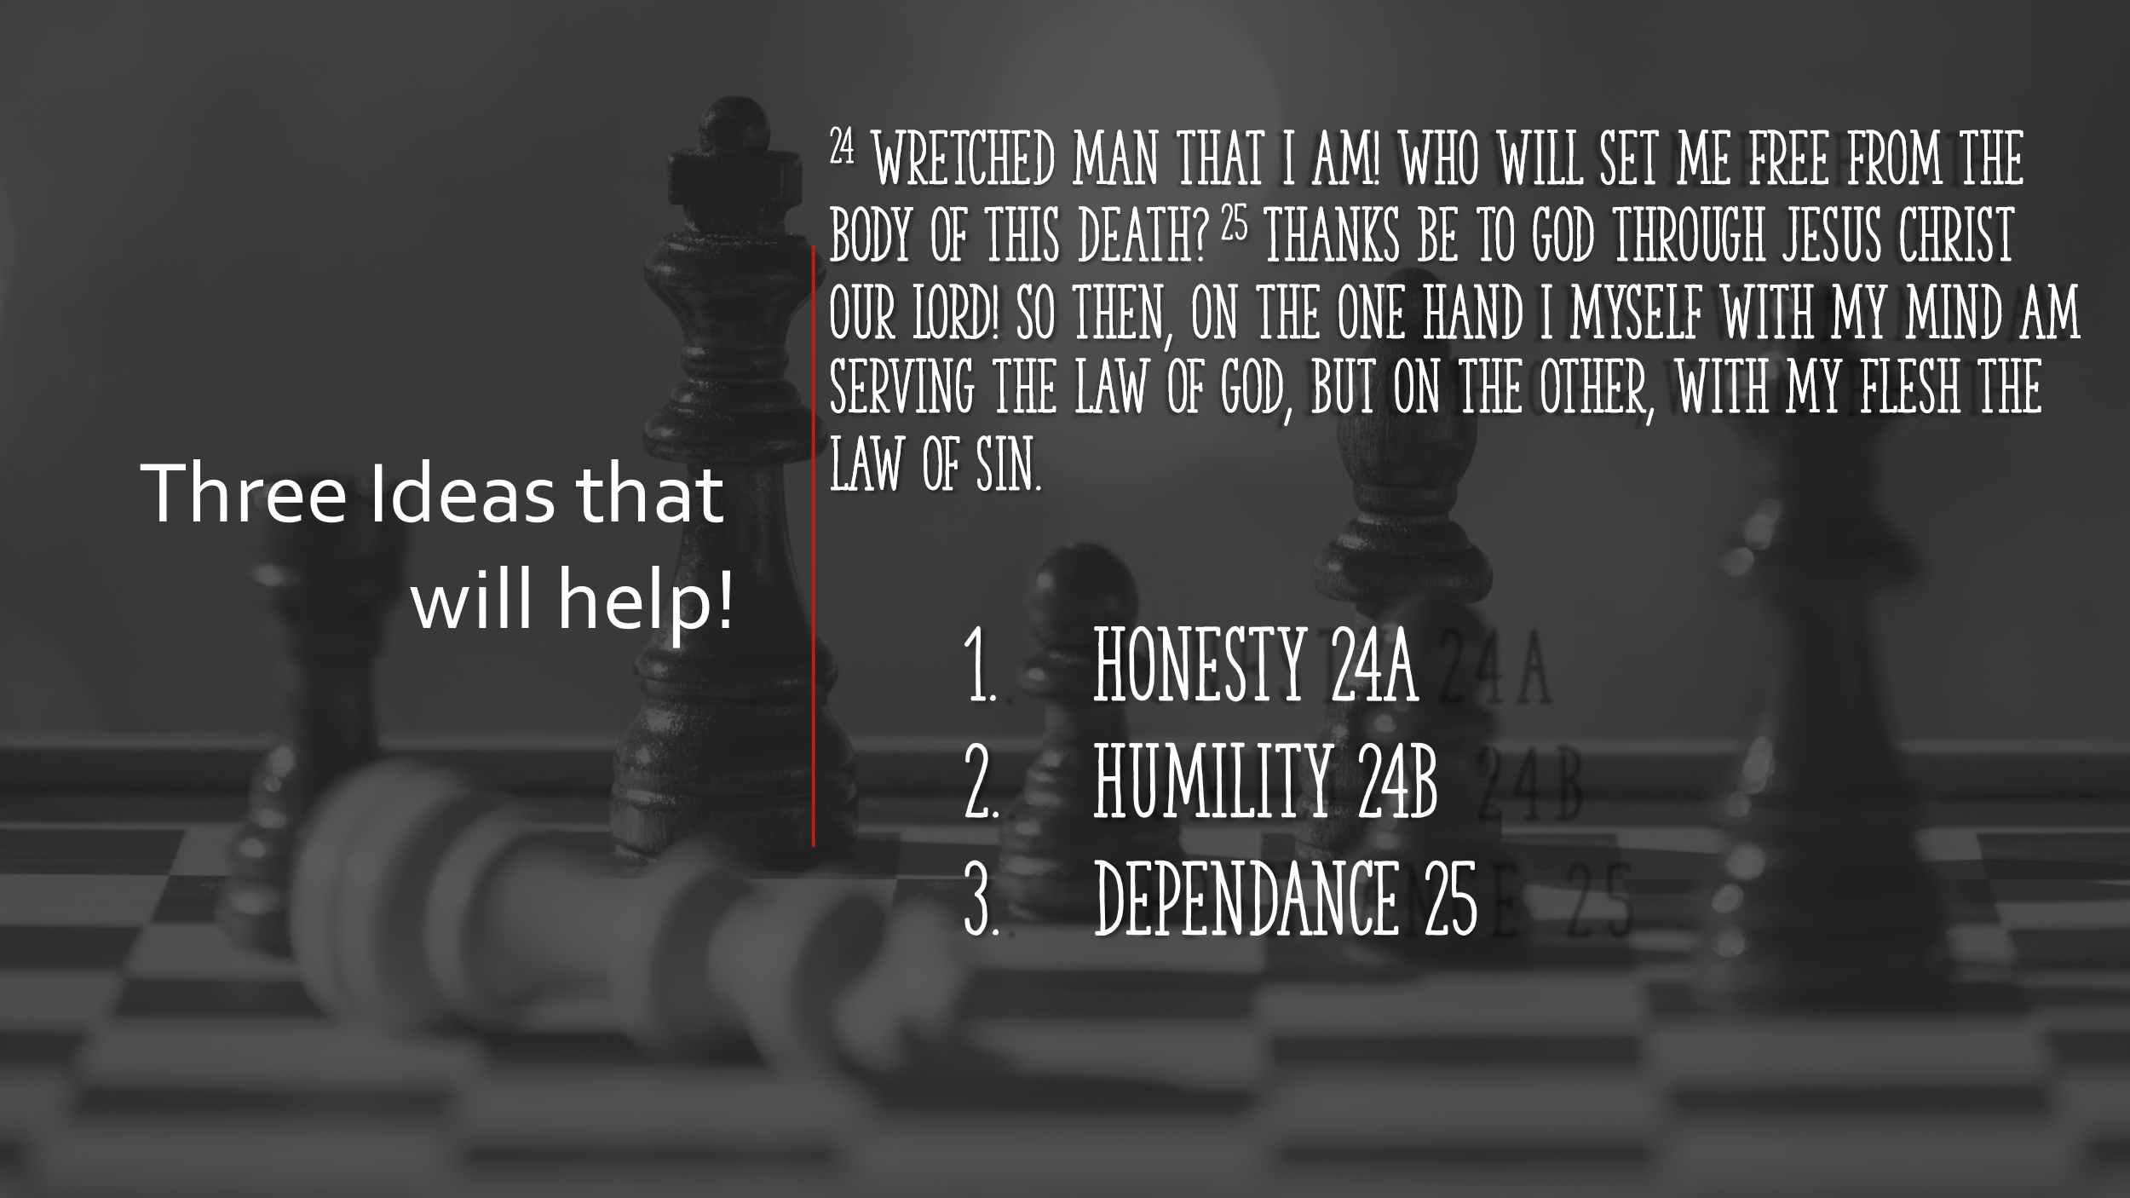
We know what is right INTELLECTUALLY.
When we see the pain of sin in our lives, we Instantly put up our deflector screens hoping that it will bounce off. We deflect the truth. We deflect the life-changing truth because it may cause us pain. Forgiving is hard. Forgiving is painful. Loving the unlovely is hard and it is painful. Living in an evil sinful world is hard. Living in an evil sinful world is painful.
We tell ourselves “I can make it on my own. And fail again and again. But without being honest about our pain and our wretched state, if we only see it as an intellectual premise, it will never hurt.
There is palpable pain in Paul’s words. He was where we are right now. The first idea that will help is simply honesty. Honesty to yourself, with your friends, with others.
I am a wretch
AMAZING GRACE HOW SWEET THE SOUND THAT SAVED A WRETCH LIKE ME…

The second idea that will help us is to be humble
We need help because we cannot do it alone. There are three things you can do with sin:
- You can deny it. “I am good, I am fine, I am handling it”
- You can try and deal with it on your own. “Keep calm and carry on.” I will tell you it does not work that way.
- Admit it and turn to God and find forgiveness.

Verse 25 DEPENDENCE
Here we come to a wonderful verse of Scripture: “Thanks be to God–through Jesus Christ our Lord!” That’s the answer to everything he’s just said about his struggle with sin. All of chapter 8 is comprehended in that one tiny statement. “Thanks be to God through Jesus Christ our Lord.” We’re going to discover that there’s a provision for victory, there’s a provision for walking in the spirit, and there’s a provision to help you win the struggle with sin. It’s all right there and we get there next week but for, now know the answer to war is dependence.
It’s not a formula; it’s a person. It is not something on the outside. It is moment-by-moment dependence on Jesus Christ and realizing that his power is enough to rescue you. You don’t have to be defeated, although sometimes you will be. You don’t have to stay in the muck and mire, although that’s where you may find yourself. Through complete dependence on Jesus Christ, there is the possibility of significant victory in your life.

