The Roman Road to Righteousness

Lesson #9 Romans 4:1-25

I was fly fishing in Northern Idaho in one of the last unspoiled, crystal-clear streams in the United States. Fly fishing is all about matching the current diet of the trout with an acceptable substitute. I was looking under little rocks trying to find the current trout menu. Each insect starts as an underwater bug hanging on the underside of rocks. I was looking for the current size and type of bug to imitate with my vast armada of exquisitely and personally tied flies. The problem was that in the bright sun on my face I could not really focus on each bug. Each little squirming larva seemed to be exactly the same. With each rock, I turned over the greater the frustration.
Then in the corner of my eye, there was a flash of reflected light. I waded a couple of feet and there at the bottom of the little creek was a pair of reading glasses. Probably lost by a fellow fisherman who probably was as blind as I.
I found my solution. The glass was intact and only scratched a little bit, but they made all the difference. Sometimes it is just better to stop and look for the blessings around us. Then and only then can we see God. All my efforts to discover were thwarted by my inability to see what was right in front of me.
Why could I not see the truth that was right in front of me?
Romans 4 starts the same way. The section starts with a question that was plaguing the church in Rome. The lack of unity, pride, boasting, and division in the church was tearing in pieces the unity of the Church.
This one question would pique the interest of the Roman moralist proclaiming, “I am a good person, I am politically correct in all I say and do, I deserve the Kingdom of Heaven.” “Paul, why are you even bringing this up.” Christianity is an exercise of the mind.
This one question would spark quick condemnation by the logical Greeks. They pointed at the Jews for their pois and overbearing privilege. They would shout from the pulpit, “We are the ones who keep the church going while you were out.” “We are the ones who toiled and fretted over the way of faith.” “We did all we did with what we had.” Christianity must be separate from Judaism.
The returning Jewish Christians continued in their demands for all converted to be circumcised as a ceremony of their being a part of the church. They demanded all hold the Jewish holidays be observed and kept. They demanded everyone in the church eat only what they ate. Christianity was a subset of Judaism.
__________________________________________________________________________________
In this struggle for dominance in the church in Rome, who side would you be a part of?
- Jewish ceremony B. Moralist contextual conformance C. Greek Intellect
Paul was driven to explain, from his own understanding, a picture or example of righteousness. There is a goal for the nation of Israel and the convent given to the Jews that was central to the Romans, the Greeks and the Jews.

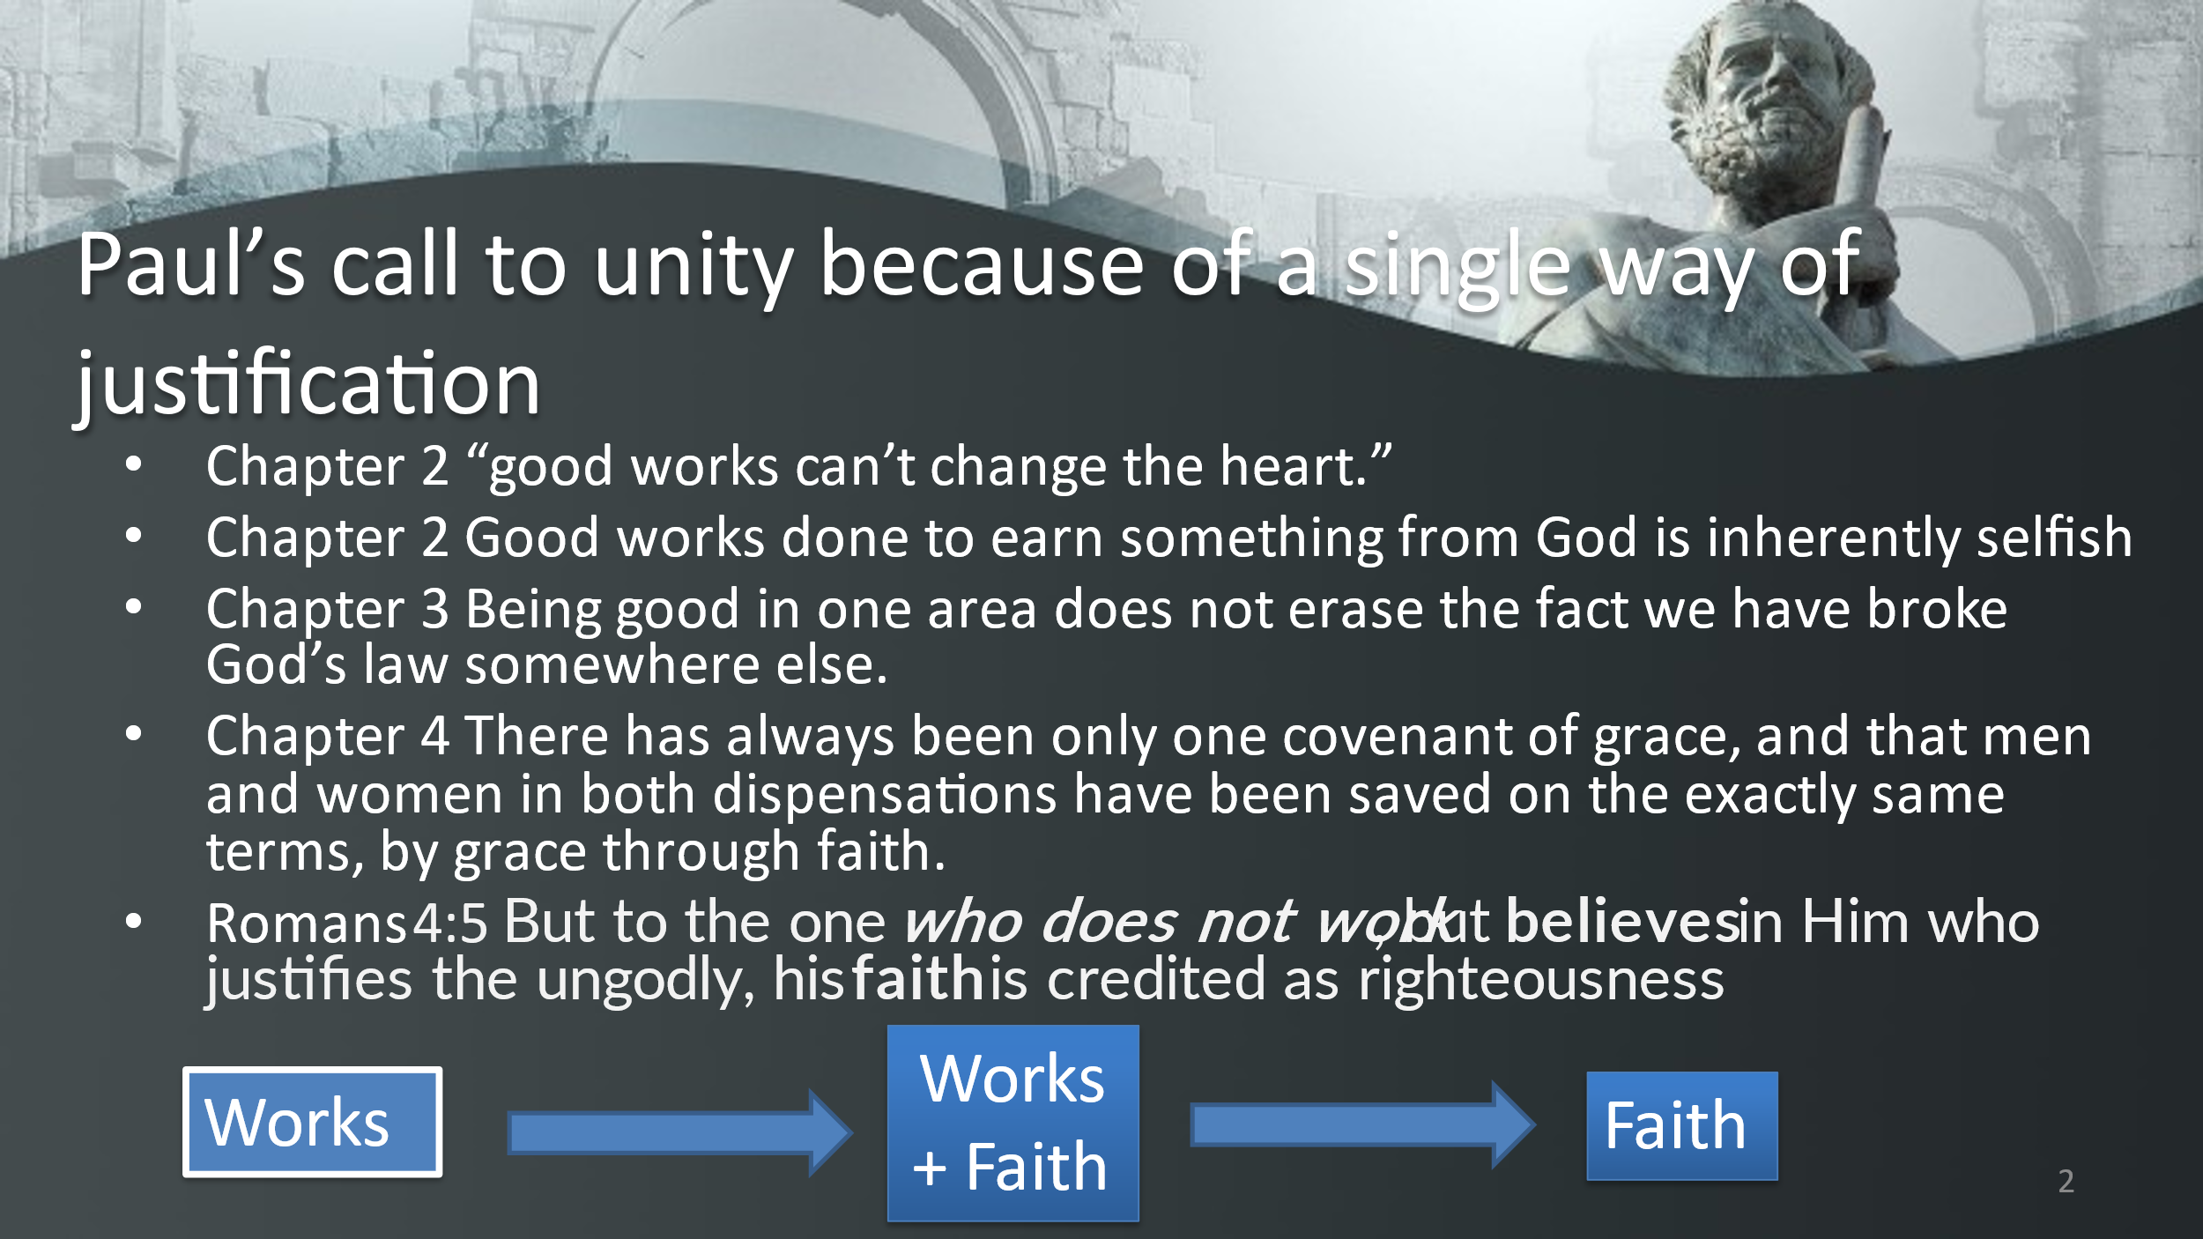

WE ARE ALL JUSTIFIED IN THE SAME WAY

So Paul chose someone that would be an example.
Abraham
The Father of the covenant people.
Last week we looked at the great faith chapter of Hebrews, Chapter 11.
Paul could have chosen for his example to the Romans:
The ancients, the chosen people who accepted there was a God
We understand that the universe was created at God’s command.
Able and his better offering were commended by God for his righteousness.
Enoch who did not experience death because he pleased God.
Noah who by faith gave up on the world and its allure by faith.

But Paul chose Abraham as his example.
Abraham before the temple
Abraham before the means and methods of Judaism
Abraham before the law as written on tablets
Abraham before the Torah

If there was ever a man that could brag about his works it was Abraham.

Romans 4:1-12 is our study for tonight.

How was Abraham Saved
Paul, because he was a Jew, took the opportunity to explain to all three groups that Christianity was not chained to any of their belief structures. It is the explanation to all three groups they needed a common belief to pull them together.

He speaks to the faction of Jewish Christians:

Rom 4:1 What then shall we say that Abraham, our forefather according to the flesh, discovered in the matter?

Paul was asking why did God separate Abraham from his culture and society to become something else? The nation Israel was to be a means to a universal end. The purpose of Israel and for that matter, the church is to invite, cajole, drag, and open doors to the world to a covenant. That, “I will be your God and you will be My people.”

Romans Chapter 4:1-9
1 What then shall we say that Abraham, our forefather according to the flesh, has found? 2 For if Abraham was justified by works, he has something to boast about, but not before God. 3 For what does the Scripture say? "Abraham believed God, and it was credited to him as righteousness." 4 Now to the one who works, his wage is not credited as a favor, but as what is due. 5 But to the one who does not work, but believes in Him who justifies the ungodly, his faith is credited as righteousness, 6 just as David also speaks of the blessing on the man to whom God credits righteousness apart from works: 7 "Blessed are those whose lawless deeds have been forgiven, And whose sins have been covered. 8 "Blessed is the man whose sin the Lord will not take into account." 9 Is this blessing then on the circumcised, or on the uncircumcised also? For we say, "Faith was credited to Abraham as righteousness."

Three possibilities for justification.
Putting back in plumb. Straightening out. Bringing in conformance with the true
1. I can rely on my own works to become right with God.
  - My wage is what I am owed for working
  - Religion based on works
  - I obey God therefore I am accepted….
  - OBEDIENCE IS WHAT I DO AND ACCEPTANCE IS WHAT GOD REWARDS ME WITH.
He owes me…
2. can couple works with my faith
  - I can believe but I have some part in it. I have to do something to earn my way.
  - Issue with that is the problem of pride and boasting.
3. I can not depend on my works and just PISTIS.

The entrance fee into heaven is nothing. It has been paid by Jesus

“Why do you think God will let you into heaven? ______________________________________

______________________________________________________________________________

WHAT IS SAVING FAITH? _______________________________________________________

______________________________________________________________________________

What saved Abraham?
Was it his works? YES NO

Abraham was our forefather according to the flesh. He was the founder of the Jewish religion. He was given a covenant to be the father of a great nation and to bless the rest of the undeserving world.

ABRAHAM WAS NOT JUSTIFIED BY HIS WORKS. IT WOULD BE SOMETHING TO BOAST ABOUT
To answer the question in Romans 4:1 What then shall we say that Abraham, our forefather according to the flesh, discovered in this matter?
The answer is: Romans 4:3 Abraham believed in God and it was credited to him as righteousness.

You are not saved because you have always believed in the existence of God
I go to church
Been a good person
Broken no laws
I have given of my time, talent, and treasure
BECAUSE I HAVE DONE THESE THINGS, GOD OWES ME HEAVEN
I WORKED I DESERVE MY WAGE.

Abraham was saved by more than a knowledge of God. Abraham was saved because he believed, and depended upon God: it was more than belief it was faith. It was not a simple understanding as something possessed but an active truth that is depended upon. It is active belief, put one's faith in, trust, with an implication that actions based on that trust may follow.

Four words in Greek that are often translated the same but do not have the same impact or volitional response.

Please note: A verb is action, a noun is a thing, and an adjective is a description of a noun.

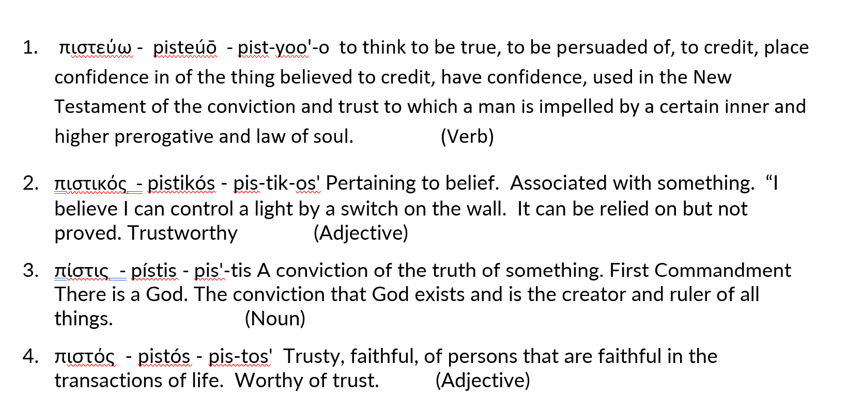
Abraham was saved by pistis belief, faith V9
------------------------------------------------------------------
Please notice in Romans 4:6 the use of “credits”. Here is the trap: We must avoid the notion that faith is a refined kind of righteousness which God accepts in lieu of Legal obedience. Faith is not depending upon nor relying on our belief. It is depending upon and relying on God.

Justification is a GOD job. Belief and faith are a man’s job.

To be justified is to declare legally righteous. It is a divine act where God declares the sinner to be innocent of his sins. It is not that the sinner is now sinless but that he is "declared" sinless. The sinner is not made righteous in that his soul is changed or that his soul is infused with God's grace.

Instead, justification is a legal act of imputing the righteousness of Christ to the believer (Rom. 4:11, Phil. 3:9). This justification is based on the shed blood of Jesus, " . . . having now been justified by His blood . . . " (Rom. 5:9).

When God sees the Christian, He sees him through the sacrifice of Jesus and "sees" him without sin.

This declaration of innocence is not without cost, for it required the satisfaction of God's Law, " . . . without shedding of blood there is no forgiveness," (Heb. 9:22). By the sacrifice of Jesus and in the "one act of righteousness, resulted in a justification of life for all men." (Rom. 5:18, NASB). In justification, the justice of God fell upon Himself--Jesus. And because of the unmerited favor of that sacrifice, we receive mercy.
This justification is a gift of grace (Rom. 3:24) and by faith (Rom. 3:28) because Jesus bore our guilt (Isaiah 53:12).

When was Abraham Justified-Counted as Righteous - Saved
The order of Abraham’s covenant and being counted as righteous and the ceremony or seal of Circumcision.
- Abraham the founder of the Jewish nation was justified long before he was circumcised.
Rom 4:9 Is this blessing then upon the circumcised, or upon the uncircumcised also? For we say, “FAITH WAS RECKONED TO ABRAHAM AS RIGHTEOUSNESS.”
Rom 4:10 How then was it reckoned? While he was circumcised, or uncircumcised? Not while circumcised, but while uncircumcised;
Rom 4:11 and he received the sign of circumcision, a seal of the righteousness of the faith which he had while uncircumcised, that he might be the father of all who believe without being circumcised, that righteousness might be reckoned to them,

It is not an outward act that justified Abraham. It was not the act of circumcision. That happened later in his life.
This raises the question of “what can I “DO” to please God.”
Everything: God desires your prayer, God desires your efforts for the poor, God desires your worship, God desires your attendance in Church, God desires your obedience.
    - But these things you do are not counted as righteousness.
    - These things you do are not a requisite for entrance into heaven.
    - These things you do are not winning you favors.
    - These things you do are not making you any more holy.
    - These things you do are not making you any more righteous.
    - These things are seen only as a personal response by a grateful being
Nothing: What do we do with those who do not work at all? Verses 4 and 5
Rom 4:4 Now to the one who works, his wage is not reckoned as a favor, but as what is due.
Rom 4:5 But to the one who does not work, but believes in Him who justifies the ungodly, his faith is reckoned as righteousness,

- When a man works his wages are not counted as a Gift. The gift is the price paid for justification. The gift is the only measure of a man
- When a man works to get himself into the good graces of God, he is saying, “ I don’t need the gift, I have earned the right.”
- God does not make us godly and then justified.
God’s spirit does not change our lives to a point we start doing and earning before we are justified
God justifies, pardon is applied to the soul
God justifies the ungodly
God can reach out to the most sinful
- Our own personal righteousness must be uprooted. It must be eliminated. Because without that elimination we will always say I deserved it.
- All religion if it a method of paying the price, whether baptism, or circumcision they are still works and will not justify. Both have value as an offering to God in response to inward change. But neither have any worth outside of new creature.

Abraham did not work at pleasing God. He was not seeking a method to please. He knew there was a God. But it went further to a faith in God. He stood before God a sinner. No wages to be paid. No wages earned. No prayer made. No sacrifice. Ungodly. Without acceptable piety.
In the question of God, “Make me a promise” said God “to obey and follow” and Abraham said, “OK I can do that.”

What importance to Paul’s theology is the timing of justification?
Paul was showing that when Abraham was counted to righteousness was before the circumcision then the act of sealing, circumcision, was to an already justified man. It was possible to be justified before the outward ceremony. The truth was it is by faith alone.
Justification is available for all people. The Christian Jews, the Moralist Romans, and the knowledgeable Greeks.
- Abraham is the father of believing gentiles and was circumcised to become father of a nation, but remained both universality – no difference between Jew and Gentile
- There is no place for gentiles to Jewish rites, of circumcision and temple, but Jews must come to a gentile faith.
- Circumcision secures a nation, not a covenant – God only promises salvation through faith.
- The Jews saw the circumcised son Isaac for the picture of a saved justified man and not in the faithful Abraham.
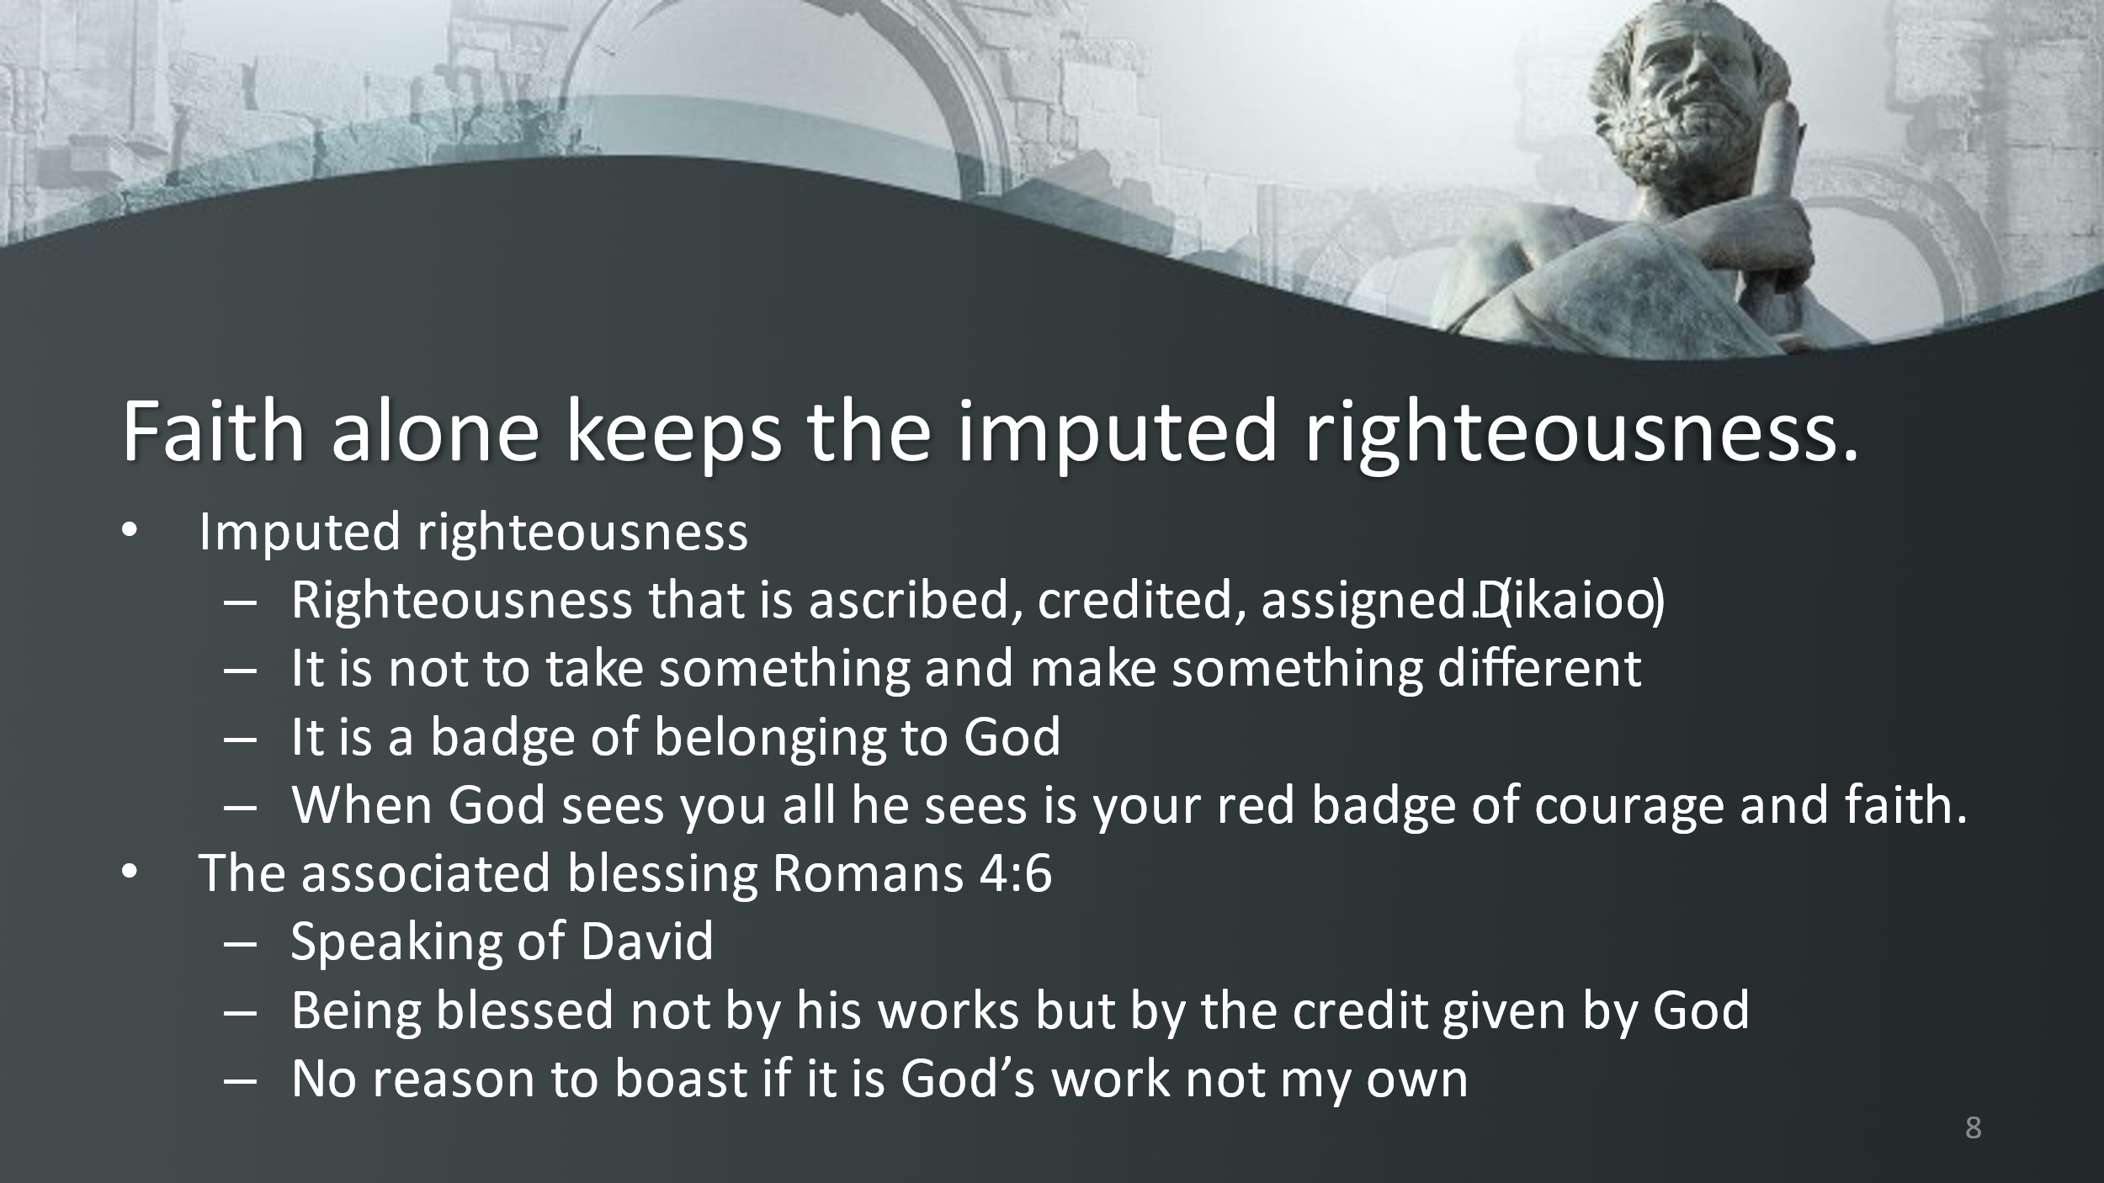

Summary
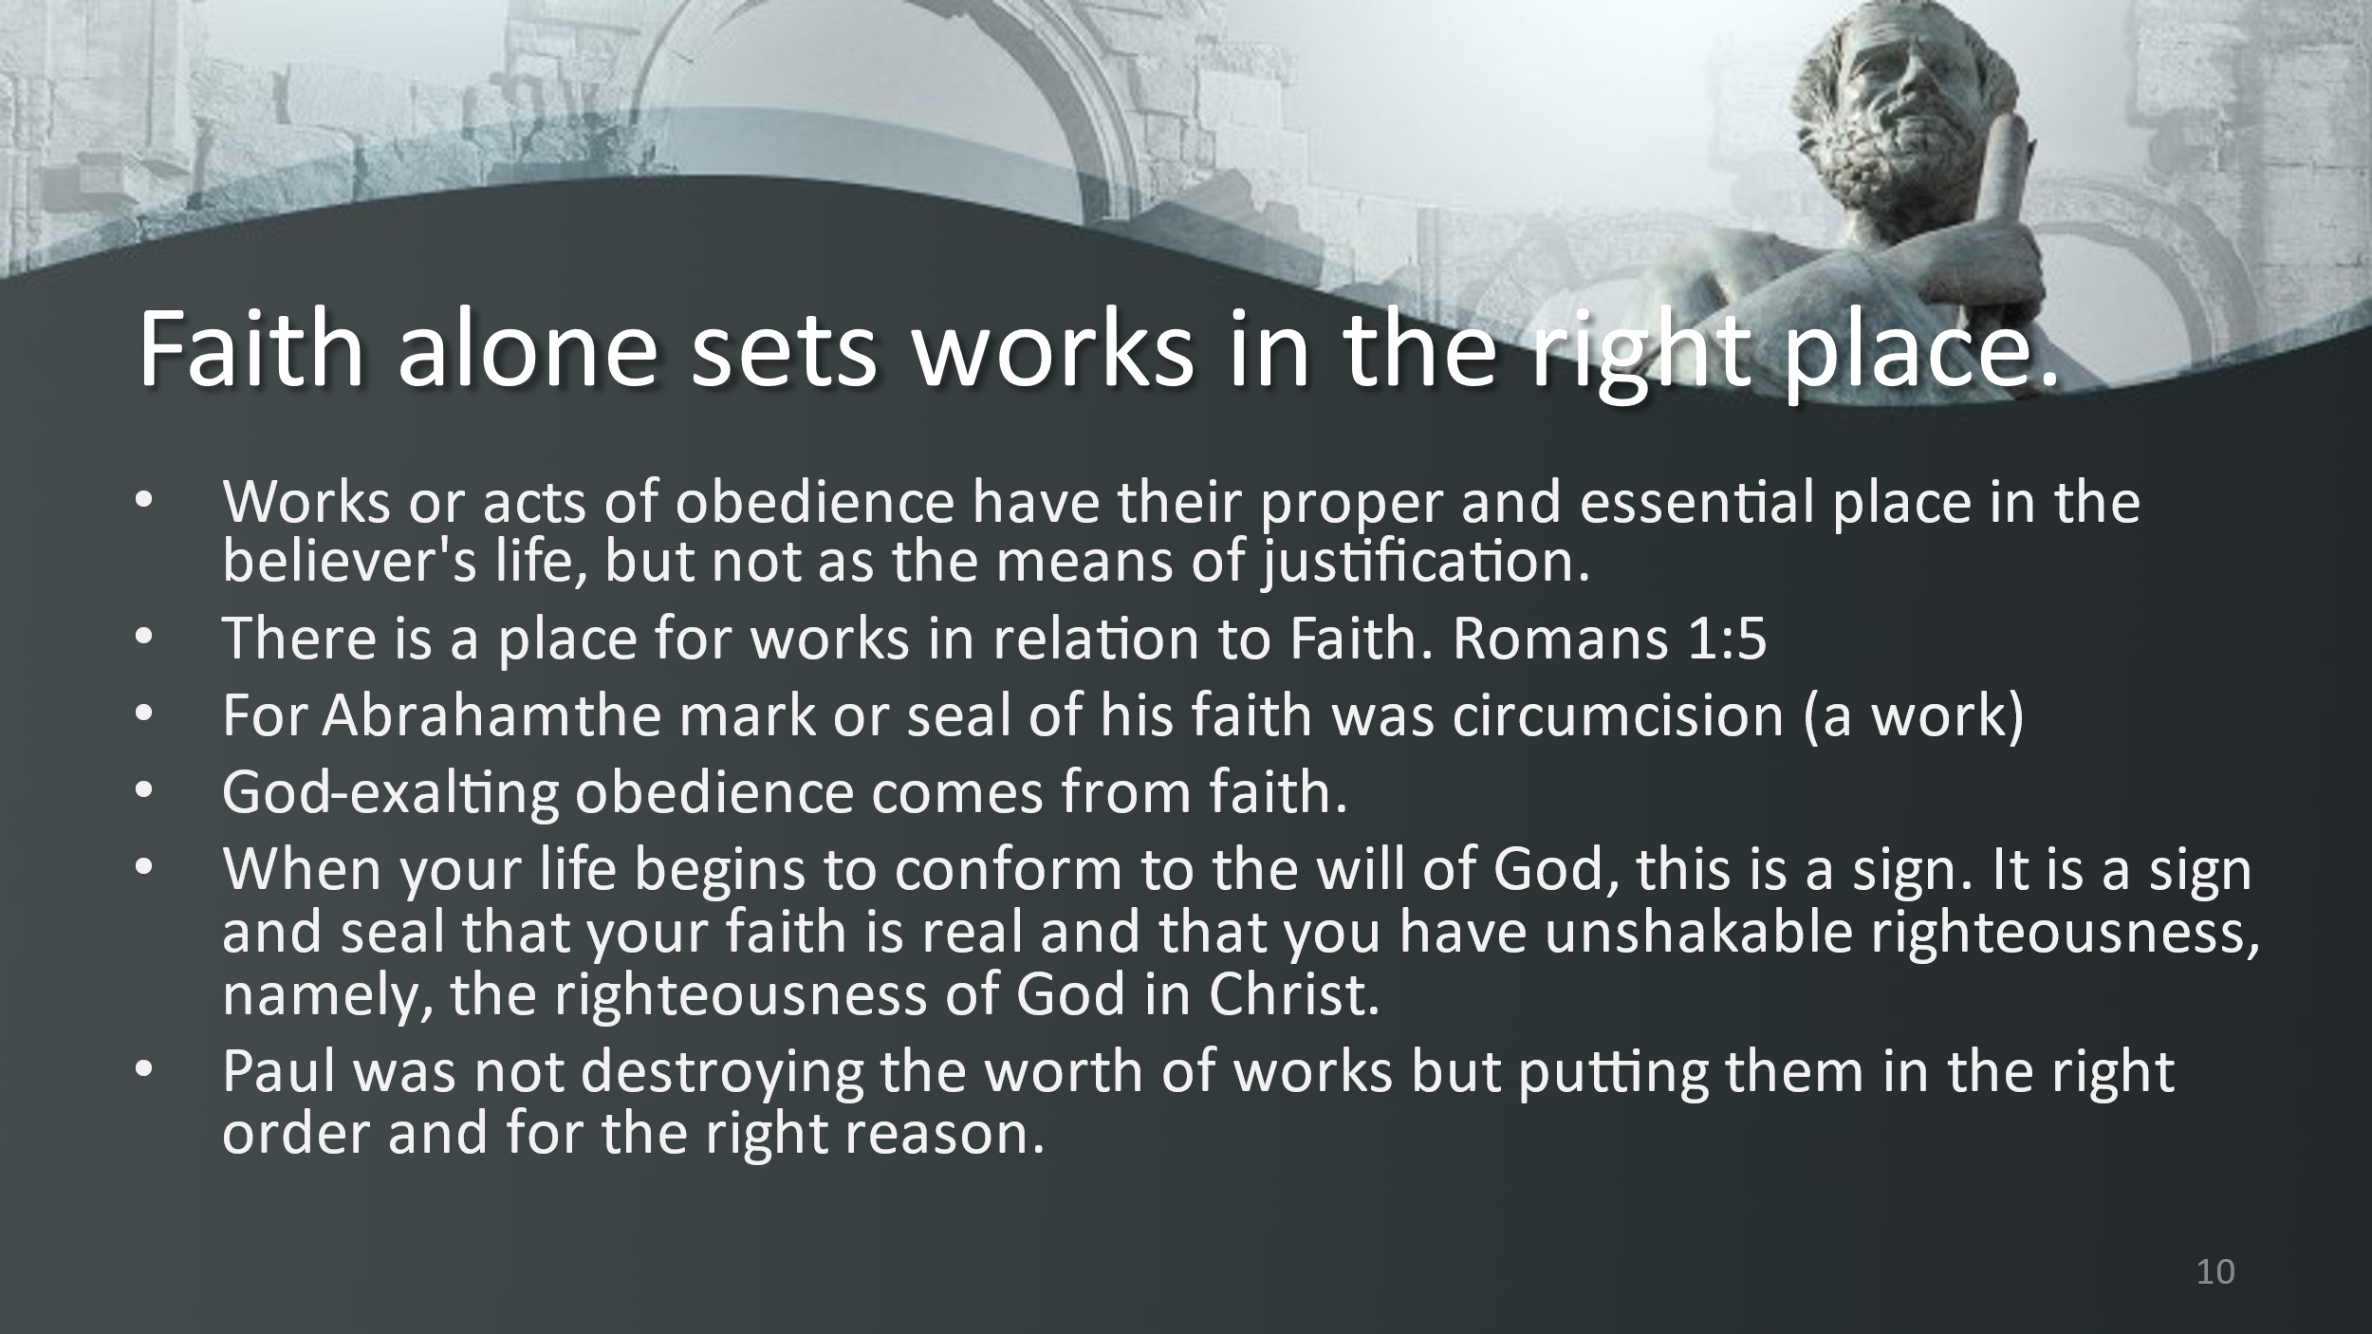

There are three very important thoughts found in this chapter.

- Justification, becoming upright, to be accepted by God as righteous, is only by faith and not by works. It is an act of God. All we bring to him is our guilt and sin. It is a complete lack of confidence in the flesh. The answer to the question, “Why should God let you into His heaven?” is “My hope is built on nothing less than Jesus’ blood and His righteousness”. We may ask, what about repentance? Wesley wrote about repentance as being, it is a conviction of sin, it is a knowledge of being lost, an understanding of offense to God, and it is the lowest form of faith. With it comes a faithful turning from sin to God. Faith itself was never seen as a work. Faith is an instrument by which we freely obtain justification. Our faith is counted for righteousness. Faith’s power or efficiency comes from God and not the self.

- Justification is by faith alone. Any ceremony, right, or observance does not justify you. Circumcision was not a requirement of justification. If Abraham had not been circumcised he would still have been the father of the a great nation. The promise was given to Abraham long before the rite was created.

Then why do we need them at all? Abraham was counted as righteous, why did he have to be circumcised 14 years later? It was a seal, a marker something that would set the covenant people apart. But it was not something that saved them. Jesus was righteous but submitted to baptism by John. This ceremony was an outward sign of an inward justification. We do rituals such as baptism and communion to be justified, but because we are justified. These rites are a mark or a seal on which what has been done, not on what is being done.

- Justification is by faith alone and not by the law. The promise to Abraham was given 430 years before Sinai. Abraham was justified by God by his faith anything added to it was of no enhancement of that justification. All the things or can do to keep the law, by my personal free will, by my own strength and resources do not justify me more than the day I was saved.

There is an inward dislike for the law. It is seen as a burden, something we have to do as by compulsion. “Here are the rules and it’s up to you to keep them.” Nevertheless, if it is me then it doesn’t have value to God. It becomes a waste.

Justification/Salvation rises and falls on this one thought: FAITH. Not righteousness from self-driven effort but righteousness outside of self. It is not relying on our goodness, but only on God’s goodness.

What is the purpose of the law? The law exposes our sins. The law brings wrath. The law does not bring salvation. The law exposes our guilt and reveals our sinfulness. Sinful tendencies may well exist without the law but are expressed in the law. God’s laws give specific commands from God that brings a bright light to the darkness of our world.

The Law brings with it sin, transgression, guilt, and wrath. And therefore the Law must be separated from the promise. The law must be separated from justification.

V. 16 – It is of faith that becomes grace to Abraham’s promise to all seed (all men) not that that which is of the law (Israel, but also to those to the faithful faith of Abraham (All believers)

Then why try to keep the law? Why not do whatever I want? Trying to keep the law to please God is to multiply our guilt our shame, revealing our state of impossibility. What is the purpose of Law but to point us to a higher sense of grace. It allows us to “search me, Oh God, and see if there be any wicked way in me.”

Ultimately The law is fulfilled in Jesus. He did not come to eliminate the Law. We still need it reveal ourselves to ourselves. The law is not for the religious hierarchy to pass down judgement. The is for personal use only. It cannot be separated from God. It cannot be divided from Christ. It will make the heart free. It will make the heart glad.
